
Cours Fireworks

Type on Path in Fireworks Tutorial
Home » Tutorials » Fireworks Tutorials
Sometimes you want your text to conform around your image, or follow a path that is difficault to acheive by moving your entire words around. The answer to to place your text on a vector path. Start off by using your text tool to write your phrase.

Click on the vector path tool by clicking and holding on the pen tool icon on your toolbar.
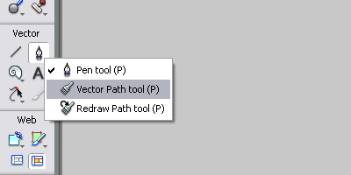
Use this tool to draw the path across your image that you want your text phrase to follow.
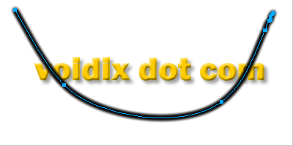
Click on both your text and your vecot oath and choose Text > Attach to Path
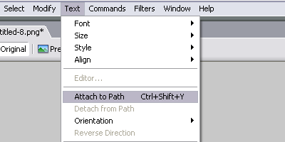
Your text will automatically follow your line, here is how mine turned out.

-----------------------------------------------------------------------------------------------------------------

Professional Text Fireworks Tutorial
Home » Tutorials » Fireworks Tutorials
In this tutorial I wll show you how to create some professional text in Fireworks. Start off by using your text tool to write your title.
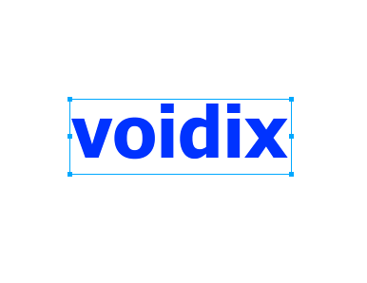
Click on the dropdown menu in your text properties tab near the fill icon to change your fill mode to gradient. Choose a linear gradient with colors of dark blue to light blue. Change the position of your gradient by adjusting the anchor points on your canvas. Place the darker of the two colors towards the top.

Now we are going to add a reflection. Duplicate your text layer by clicking on the corner of your layer meny and choosing Duplicate Layer.
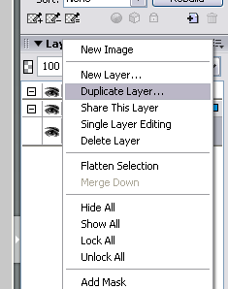
Rotate your text by choosing Modify > Transform > Free Transform.
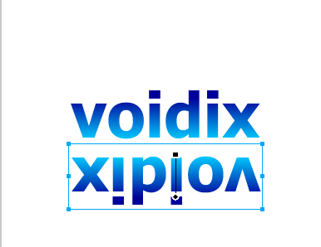
Now we need to match up the letters by flipping the text around. Choose Modify > Transform > Flip Horizontal.

3D text with Fireworks.
In this lesson you will learn: How to make the 3D text this time the lesson will be professional, and the text will matches the 3D programs.
In this lesson we will repeat layers and dealing with Fireworks filters attached to the program.

Tutorial begin:
Open the Fireworks program and start work fits 600 × 200 pixels and the background white.
Write what you want (YAMON will be used in the lesson) by selecting writing tool and make this text options like the one in the following picture:
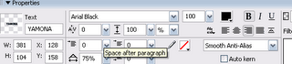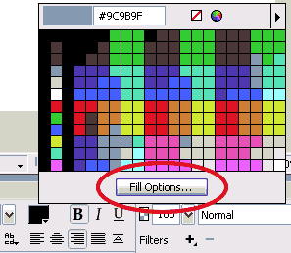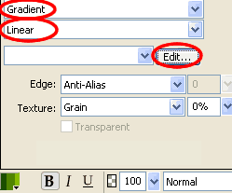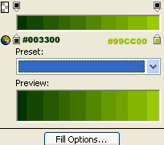
Use Scaling "skew" tool to make your work like the one shown in the following picture:
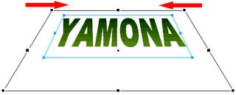
Now make 2 versions of the work through the Edit menu then Clone twice(Ctrl+Shift+D) to get the list of the following layers:
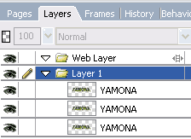
Now locate (select) the middle layer, click on the Filters then Shadow And Glow then select Solid Shadow noted the following image:
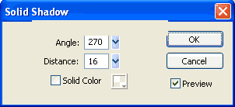
Chose the upper layer and change the color of your text to the White, layer type to Fuzzy light, and chose filter Filters - Blur - Gaussian Blur value 1.4 ... noted the following image of the layer:
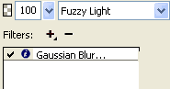
Chose the lower layer ... change the text color to black color filter giving Filters - Blur - Gaussian Blur value 1.2 .. Thus, we obtain the following format for the layers:
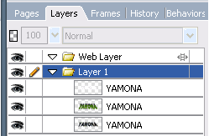
Output Module


Icon in Fireworks Tutorial
Home » Tutorials » Fireworks Tutorials
In this tutorial I will show you some basic techniques in creating simple yet pleasing icons in Fireworks. Start off by creating a new file, and using your elliptical marquee tool to make a circular selection. Fill your selection with a radial gradient, making sure that your inside color is lighter than your outside color. Position the start of your gradient in the top-left corner, and let it radiate downward and to the right. Your image should look similar to mine.
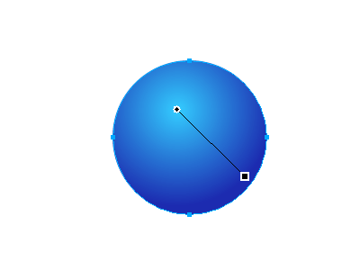
Use your Ellipse tools to create a new circle smaller than your first. This will act as a highlight reflection. Position it towards the top of your original circle, and charge the gradient colors. Change your light color to white, and lower the opacity of your darker color to 0. Apply your gradient to your selection.
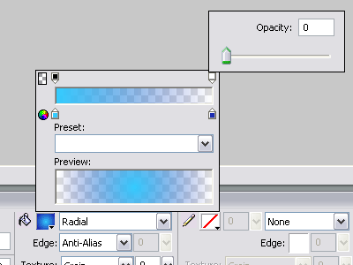
Use your text tool to create a character to represent your icon. I used an @ symbol, which would make a good "contact" icon. Position your text towards the bottom of your circle so that part of the text bleeds into the white background, as shown below.
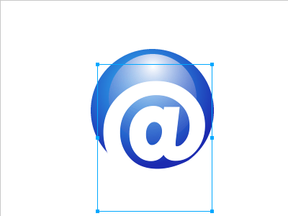
Duplicate your text layer by clicking on the icon towards the top left corner of your layers tab, and choosing "duplicate layer". Change the colors of your original text to a dark blue.
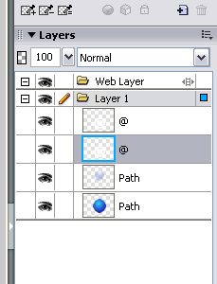
move the bottom of the two text layers two pixels upward and two pixels to the left. This will give your duplicate layer an inlayed effect.

Apply a gradient to your white text of light blue to white, making sure that the light blue color starts at the top and radiates downward. This will increase the depth of our inlayed effect.
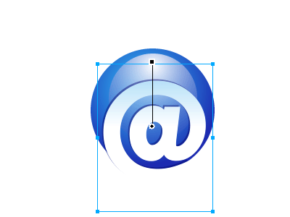
Next I converted my layers to bitmap by pressing Ctrl+Shift+Alt+Z, and merged them together by clicking Ctrl+E. Now that they are bitmap I can use the erasers tool to clean up the unwanted edges created by the dark text layer.

Here is how my finished icon turned out.


Artistic curve logo

- 1
- 2
- 3
- 4
- 5
(11 votes)
Written by DanielRo
Before you start this tutorial you should consider this is just a "how to", if you are working for a company and you need a professional logo you should try a Custom logo and web design service - Special Deal for your Business .
Step one (Creating the shape)

Create a new document, lets say 300x100 px with a background color of your choise, im using White (#FFF).
Next chose the Pen Tool (P) and draw a shape like you see in the image below :
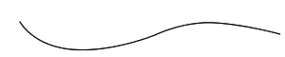
You will need this shape later on in the tutorial, so its a good ideea to copy and paste this shape in a new Fireworks Document.

Next select the shape, and clone it. (Ctrl+Shift+D). Then move the selected cloned shape up 10px. You should end up with an image like the one below :
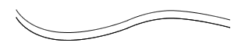
Now we need to join the ends of these to shapes, to generate one master shape. Chose the Subselection Tool (A, 1) and folow my steps :
1. Click the Top shape, when its selected you will see some points. Look at the image below :
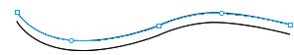
2. Now click the 1st little square from the left, on the top shape. Click and drag it down so it joins the 1st little square from the left, on the bottom shape. Look at my image :
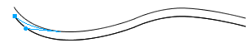
3. Now do the same on the ond of the two shapes. You should end up with an image like the one below :
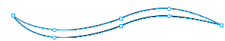
4. Now we need to merge this to lines, and create one master shape, so we can add all our effects and color fills.
Select both lines then go to : Modify > Combine Paths > Join (Ctrl + J)
5. Now that we have our shape we can add a color fill. I am using #006699. Now that you added the color fill you may notice that your shapes has some bugs wrong curves. Using the Subselection Tool you can select every "dot" on you shape and bring it to a nice smoothe shape. Take a look at my shape after about 5 minutes of tweaking :

Step two (The effects)
1. Now to begin we need to change the fill from solid to Gradient > Ripples.
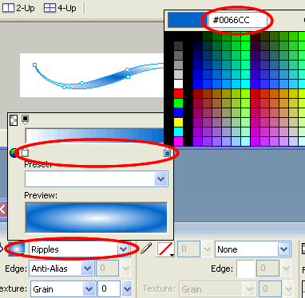

2. Now select the shape, Goto : Filters > Shadow and Glow > Drop shadow
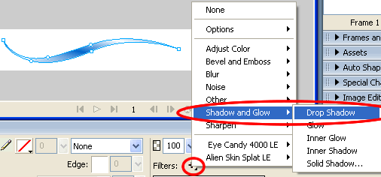

The default drop shadow settings is not right for us, so you should use the settings like you see in the image below :
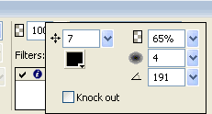

You should end up with an image like the one below :


Step three (Creating the text)
In this part of the tutorial we will be creating the curved text and apply it to the shape.
Using the text tool (T) enter your text, in this case im using "Tutorial5.com".
Now remember in the start on the tutorial when i told you to save the 1st path to a new document ? This is the time you will use that shape.
Copy that new shape and paste in the stage (Curent documment). Now select both the shape and the text and goto : Text > Attach to Path (Ctrl + Shift + Y) :
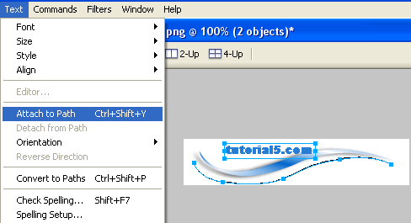

Now do the same thing for the other part of the text, paste the shape in the document again, create a new text and attach it to that path.
For a better understanding of this tehnique you should check out our tutorial on TEXT TO PATH .
Now you may notice that your text is on the path but its not quite exact. In our original image the text looked alot better and thats becouse we tweaked it abit. For the sake of keeping this tutorial simple im not going to take screen shots of this proccess but i will explain it.
After you attached your text to the paths you can go ahead and Select the text you want to tweek and then goto: Text > Convert to paths (Ctrl + Shift + P). This will break up the text in paths, allowing you to edit the position and shape of every letter.
I played a little with my shapes and ended up with this


Create Mac-like wallpapers with Fireworks
Posted in Effects by Justin

Welcome to the very first tutorial of firetuts.com. I will show you how you can easily make one of those sleek abstract wallpapers you’ve probably seen before, with Adobe (or Macromedia) Fireworks. I shall give credit to Collis for the original tutorial for Photoshop. This tutorial, however, will also teach you a trick to color it in a different way.
1. Create a canvas in any screen size you want, (800×600, 1024×768, etc.) and set the canvas color to #CCCCCC. I use 1200×900 because I’m a widescreen fan.
2. Next, draw an oval and shape it like so; I assume you know would know how to do that. Set the fill to linear gradient and adjust the colors to #CCCCCC on one side and #FFFFFF on the other. Adjust the gradient positioning like so.
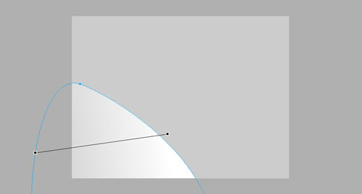
3. On top of that, create another oval and shape it like so. Set the linear gradient to #CCCCCC and #999999. Set its opacity to 50%.
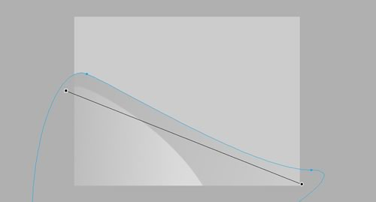
4. And on top of that, create an oval but this time with an inverse curve like so. Set the fill to radial gradient with #FFFFFF on both ends, and adjust the outer edge to an opacity of 0%. Position the gradient at the top of the canvas like so. This will make the top side of the oval glow white.
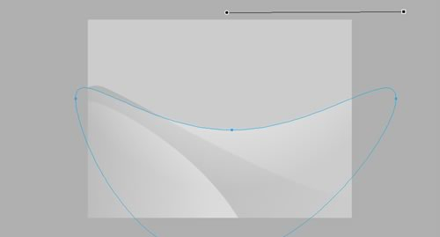
5. Draw one more oval with linear gradient of #CCCCCC and #FFFFFF, like so.

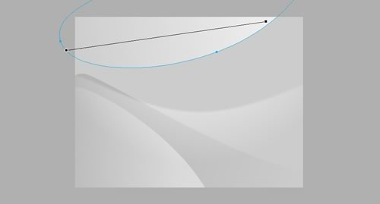
Now select all the ovals and set it their Feather value to 2. This will make its edges blend better.
6. Now, draw a rectangle the size of the canvas, set it to ellipse gradient with white on both ends. Change the opacity of the edges to 0%. This will make a nice white glow in the center of the image like so. Set its opacity to 50%
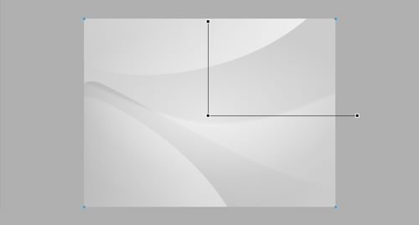
7. Also, set that rectangle to overlay, something that I found to be really sweet feature.
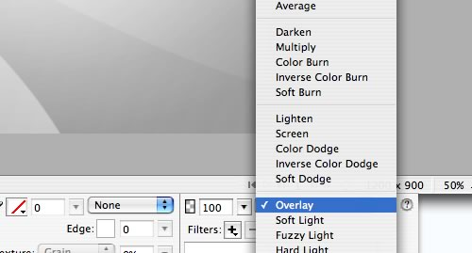
8. Create another canvas-sized rectangle on top of that, and set it to radial gradient with #000000 on both ends and opacity of edges to 0%. Set that to overlay. This will complement the white glow in the center better, by making the edges darker.
9. Now here’s the coloring trick. Draw another rectangle the size of the canvas and fill it with any solid color you want, I shall use green. Set that to overlay. With that you will get a nice array of green shades future-style.

BONUS TIP
To make the colors even MORE interesting, first draw another canvas-size rectangle on top of everything and set a black-and-white vertical gradient like so.
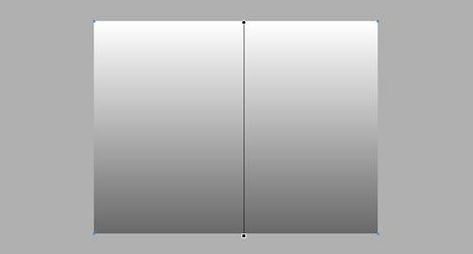
Set that to overlay and watch the magic happen.

It’s little brighter but you can adjust its opacity in any way you want.
The basic idea of this this type of ‘digital abstract art’ is to play around with vectors, gradients, and opacities. And my coloring techniques are basically gradient overlays. You can adjust anything to your liking and you will most likely make a better wallpaper than this one here.
If you have anything to add, you are most welcome to leave a comment. In fact I even accept criticisms.

